

**PDPM INDIAN INSTITUTE OF INFORMATION TECHNOLOGY, DESIGN AND MANUFACTURING JABALPUR**

**Madhya pradesh-482005, India , 2022**

DS3001 Engineering Design and Fabrication project

TAGGING AND TRACKING OF AN AMNIMAL

**MENTOR**: **DR. TRIPTI SINGH**

* 20BCS115 KOKKIRALA ABHINAV
* 20BCS117 KOLLI VENKATA NAGAPAVAN
* 20BEC057 KORTTADA RAHUL
* 20BEC124 YALLAMARAJU SAI KIRAN
* 20BEC053 KAYYALA PAVAN KUMAR
* 20BDS042 THEJAS N K
* 20BME019 BHUCHARALA CHARAN

**INTRODUCTION:**

Animals are very good friends to the humans. Especially pet animals are living like a family members like dog, cat, buffalo, etc. If for example our pet animal is missed or it gone to some other place or it is attacked by some other wild animal when pet animals are leaved the house accidently.so, this device is help to give the notification when the pet animal is went out of place from house. Owner can easily find his animal exact location with help of online maps.

**The pie chart given the information about pet animals missing:**

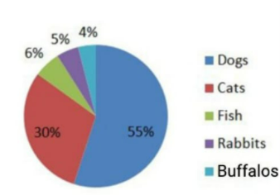

**PURPOSE:**

Due to Missing of the pet animals we are students discuss about this issue and make one solution and that is Idea A TAG with the TRACKER. It will help to find the animal when it has gone to danger place and owner felt happy because he find his pet and it has been saved from wild animals as well. And many incidents of missing the pet animals is more in buffalos and we implement this idea in buffalos, cows. It will help us to find the buffalos and cows immediately and people also who are depend their li on the buffalos, cows. And government also will be benefit about this idea if any buffalo or cow will killed by wild animals government want to pay some amount of money to family who are depend upon buffalo and cow.so government will pay any amount when the buffalo or cow will find.

**CONCEPT:**

Our project aims to develop a TAG that is with the TRACKER it is hep to find the pet animals where the pet animal is present when it is accidently went out of range from the Home and the TAG is has some unique specifications like QRCODE and UNIQUE NUMBER help to identification of uniqueness of the TAG and QRCODE is help to store the information about the pet animal and owner.

# REQUIREMENTS AND USE CASES:

|  |  |  |
| --- | --- | --- |
| **S.NO** | **COMPONENTS** | **EVENT OF USE** |
| 1. | TRACKER | IT IS HELP US TO TRACK THE ANIMAL. |
| 2. | TAG | TO TAG THE ANIMAL. |
| 3. | QR CODE | HELP TO ENTER DETAILS OF THE OWNER AND ANIMAL. |
| 4. | SPECIFIC NUMBER | IT IS HELP TO FIND THE TAG IDENFICATION OF THE TAG MUST BE UNIQUE. |

**Schematic diagram**:

THE SPECIFIC NUMBER IS HELP TO IDENTIFICATION OF THE TAG MUST BE UNIQUE.

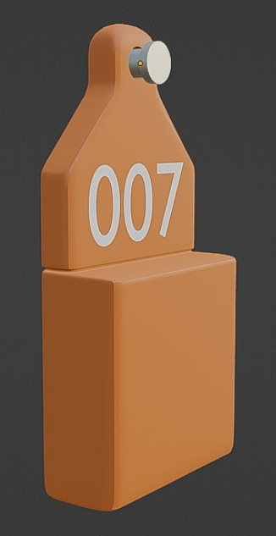 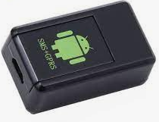

THIS TRACKER IS KEPT INSIDE THE TAG

WHICH IS CONNECTED TO SATILITE.



THIS QR CODE IS PASTE ON THE TAG

GIVE THE INFORMATION ABOUT THE ANIMAL.



**Workflow diagram:**

MAP THAT INDICATING THE BUFFER ZONE.

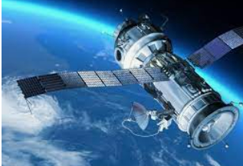

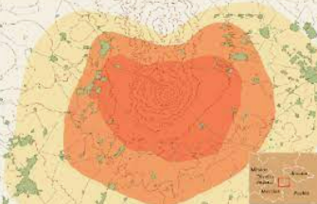

SATILITE WILL SEND THE NOTIFICATION WITH LOCATION TO MOBILE WHRE THE ANIMAL IS PRESENT.

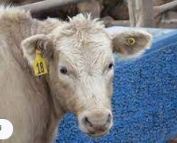

THIS TRACKER CONNECT TO THE SATILITE WHEN THE ANIMAL ENTER IN TO BUFFER ZONE.

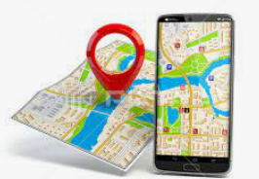

ANIMAL HAS GONE TO SOME WHERE.



BUT IT IS WITH THE TAG AND TRACKER.